School Holiday
Marine Education Program

About the Program

We invite children who have special interest in wildlife to take part in our Dive In School Holiday Marine Education Program. As you may well know, our oceans are full of amazing creatures and of particular interest to many are the highly intelligent, playful and friendly dolphins. During the program, children will have fun learning about the world of dolphins and other sea creatures and how they can help to protect and conserve our oceans.

Our holiday program is divided into three components; a learning circle, art & craft activity and a beach walk.

During the action packed 2hr, some of the activities that we can explore during the sessions together are:

- Arts: watercolour, colouring, craft (each child will take home a special creation)
- Learning: Cooperative Games, Story-telling, Songs and Dances
- Action & Connecting: Beach walk & beach clean-up

Each session is facilitated by our Dolphin Research Australia marine education and research team. Our educators have years of experience in teaching children and adults about the marine environment. Our Dolphin Research Australia volunteers will also assist in the facilitation of sessions.

Our programs provide a great experience for you and your child/ren. We encourage parents/guardians to participate in the programs and do find that it is a special experience for all.

About Us

Dolphin Research Australia is a marine conservation charity that is working to increase the understanding of the ecology of dolphins, whales, their needs for survival and to improve conservation efforts. Our projects are diverse, from developing early primary education programs and adult education programs to research that investigates the habitat use, abundance trends and social systems of dolphins and other marine species. Each of these projects aims to increase the awareness and engage the public in marine conservation efforts and increase the knowledge about dolphins and their marine environment.

Your Facilitator
Isabela Keski-Frantti
Education Program Manager
Isabela loves working with children. Her background in education and psychology has allowed her to develop resources for primary school students that focus on self/group/environmental awareness. She is originally from Brazil, where she taught English at primary and language schools for over ten years. She also graduated in clinical psychology. Living in Australia since 2004, Isabela has worked at Sathya Sai, a primary school based on Human Values, for over seven years. She works as a Child Support Officer and her background as a group facilitator involves psychodrama, group dynamics, sacred circle dances, cooperative games, emotional literacy and education in Human Values. Her passion for dolphins has inspired her to raise awareness about these fascinating creatures and their environment through education.

Enrolment Information

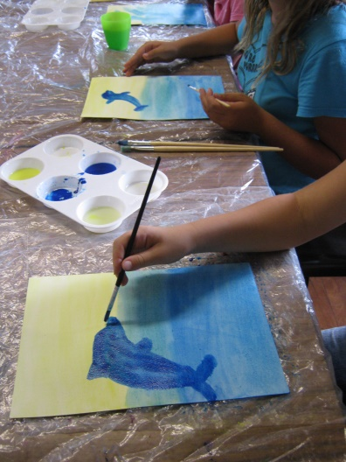
Ages: 6-11years

Bookings
An enrolment form is required (attached below) for your child/children who would like to attend the School Holiday Program. Advanced bookings are preferable to ensure your child/ren have a place in the program and that we can plan appropriately. Once the completed enrolments have been received your booking will be tentative until full payment has been received. We accept online transfers (see details below) or upon arrangement cash on the day. You will receive confirmation of your booking via email. Please ensure that you include a current and correct mobile contact and emergency contact in your enrolment form.

Confirmation & Cancellations
Once Enrolment has been processed, confirmation will be given via email or phone. If you need to cancel the enrolment, please contact us by email or phone as soon as possible. A full refund will then be issued via online direct debit transfer.

Fees
Dolphin Research Australia Inc. a marine conservation charity. We request fees for this program to assist in covering the cost of facilitating the school holiday program. Financial contributions associated with the enrolments for this program are considered a donation to the organisation. We thank you in advance for your support!

- $30 per child
- $5 for parents/guardians if you would like to participate in craft activities (otherwise you are welcome to attend free)

Bookings and payment can be made directly through our website at:

https://www.dolphinresearchaustralia.org/product/school_holiday_program/

Hours of Program

The hours of the school holiday program will be no longer than 3 hour durations as specified in the Dolphin Research Australia school holiday program timetable online (www.dolphinresearchaustralia.org). Participating children not accompanied by an adult attending the program must be met promptly at the end of the session. We are not a vacation care service, but a community education service provider.

What to Bring

Please bring along:
- Water
- Snacks
- Hat
- Shoes
- Sunscreen

As part of the holiday program sessions, we go for a short beach walk and beach clean-up, so please make sure your children have the above for their safety.

Contact Details
Isabela Keski-Frantti
Education Manager, Director
Dolphin Research Australia
PO Box 1960, Byron Bay, NSW, 2481
E-mail: isabela@dolphinresearchaustralia.org
Ph: (02) 6687 1473
Mobile: 0430223250
Website: www.dolphinresearchaustralia.org
ABN: 42095866467

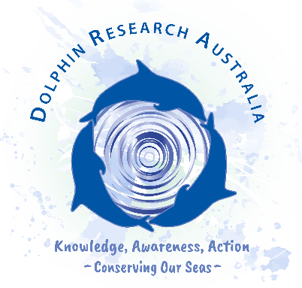
School Holiday Program
Enrolment Form

Child’s name 1:

Age:

Child’s name 2:

Age:

Child’s name 3:

Age

Parent/Carer names:

Address:

Phone numbers: Mobile:

Email:

First language:

Please let us know if there any allergies/ medical conditions and provide details of medication if appropriate:

Does your child also require any assistance with learning, mobility, community, interpersonal or other needs?

Has your child received all immunisation requirements including Tetanus?

Date of Program you would like to enrol for

Will the Parent/Carer also be attending?

In the case where you as the Parent/Carer won’t be attending the session with your child/ren, please provide the name and contact details of the person with permission to pick your child/ren up from the venue.

Name:

Address:

Contact number:

Email:

How did you learn about our program?

Website
Newspaper
Poster
Flier
Other _______________

Authorisations and Conditions of Care
Parent/Guardian Declaration

For the children listed above to be enrolled in the Dolphin Research Australia Inc. school holiday program please complete the following (please circle):

- I/we give permission for my child/ren to attend the Dolphin Research Australia Inc. school holiday program and be supervised by the Dolphin Research Australia staff and volunteers for the duration of the session. Y N

- I/we understand that I must be contactable via phone during the specified hours of the holiday program. Y N

- I/we understand that the child/ren must be picked up by myself or the specified persons above I have given permission to, promptly at the completion of the session. Y N

- I/we give permission for the child/ren to attend a beach walk and clean up during the session. Y N

- In the event of accident or serious illness of my/our child/ren, I/we give permission for the staff to seek medial attention or arrange an ambulance if considered necessary for the welfare and safety of my/our child/ren. I/we understand that I/we will be required to pay for any costs incurred with transport and/or treatment of my/our child/ren. Y N

- All participants have not been in contact with someone that has had Covid-19 in the last 14 days. Y N

- All participants have not been in a Covid-19 hotspot in the last 14 days.

Y N

- In the case I/we am attending the session with my/our child/ren, I will take responsibility for your child/ren during the session. Y N

The information I have provided in this form is correct.
I/we agree to abide by the conditions specified and of Dolphin Research Australia Inc.

Parent Signature:

Date:

Please return this form to isabela@dolphinresearchaustralia.org

