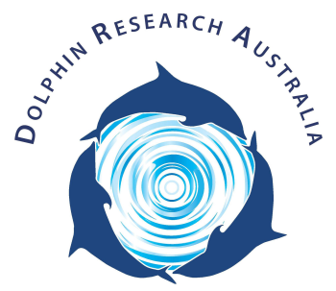
Dolphin Research Australia Inc.
Moreton Bay Dolphin Ecology Workshop
Booking Form
Please complete the below form and send to us at info@dolphinresearchaustralia.com to confirm your booking.
Name of Participant:

First Name: __________________________________ Surname:_____________________________

Address:

E-mail:

Phone number:

Price:
- $55/person for non-members; $50 for current members
- Child $30
- Family of 4 $160 (please contact us for pricing if you have a larger family)
- Family includes 2 adults and children 16 years and under
- If you would like to make a group booking, please contact us for a price

Total Workshop Fee due:

Please select payment method (highlight selection)

Made electronically Cash on Day

Do you have any medical conditions?
Please inform us of any conditions that we need to be aware of.

Do you have any dietary requirements (including allergies & intolerances)?

Declaration
- I understand that during the workshop, I will be required to follow the instructions of crew to ensure my personal safety and the safety of others while onboard the vessel.
- I understand the cancellation policy terms (outlined below).
- I agree to my personal details being held in a secure place at Dolphin Research Australia’s registered place of work.
- I understand that the booking fee includes a complementary year membership to Dolphin Research Australia.
- I have disclosed medical conditions which may pose a risk to yourself or others.
- I wish to participate and do so entirely at my own risk of injury or bodily harm to myself.
- I hereby release Dolphin Research Australia Inc., all employees, staff, assistants and volunteers or any other persons involved in my participation in the role I have with the organization from any suit, demand, action, claim for compensation whether for personal injury or damage to property arising from my participation.
- I am 18years or over and am legally competent to sign this agreement.
OR
- My parent or legal guardian has signed this form to consent to my participation. (Please state full name of parent or guardian below signature)

Signed :

Date:

Cancellation Policy
Dolphin Research Australia realizes that most people who cancel their booking do so out of necessity. However, cancellations are costly to administer and involve time and resources of the organisation. Therefore, all cancellations after booking are subject to deductions to help us cover the organisations administrative expenses (which we do as volunteers).
In the event of a cancellation by the participant:
- Cancellation more than 48hrs prior to workshop will receive 100% refund.
- Cancellation of less than 48hrs prior to the workshop will not be refunded
- There are no refunds after the starting date of the workshop. If the participant fails to join the program or leaves the program at any time, no refunds will be issued.
*Please note in the unlikely circumstances where the expedition is cancelled by the organisation if the participant level is below the required number or natural disasters or other external events, you may choose between us applying the amounts paid toward an alternative date or workshop or receiving a full (100%) refund. In the circumstances where there are too few people for the workshop to go ahead, the organisation may request a change of dates or alternatively you will receive a 100% refund.
The organisation is not responsible for any incidental expenses that you may have incurred as a result of your booking such as travel expenses.

Contact Details
Please do not hesitate to contact us if you have any questions regarding the expeditions and reservations process at
Email: info@dolphinresearchaustralia.com
Ph: 0407646069
Website: www.dolphinresearchaustralia.org
ABN: 42095866467

** Dolphin Research Australia Inc. is a marine conservation, education & research charity –find out more about us & how you can help at www.dolphinresearchaustralia.org **

